**CS5551 Lab Assignment-2**

**Nam**e: Siva Sameer Krishna Yarlagadda

**Class ID:** 57

**Team member:** Vivek Maliye

**Class ID:** 33

Part 1 Video link: <https://www.youtube.com/watch?v=a4bQhhtlSm0>

Part 2 Video link: <https://www.youtube.com/watch?v=DFuHH650YkQ>

**Part-1**

**Objective:** To develop an Android application with the following features

1. **FireBase Login and Registration:**

FireBase authentication is used for logging into the application.

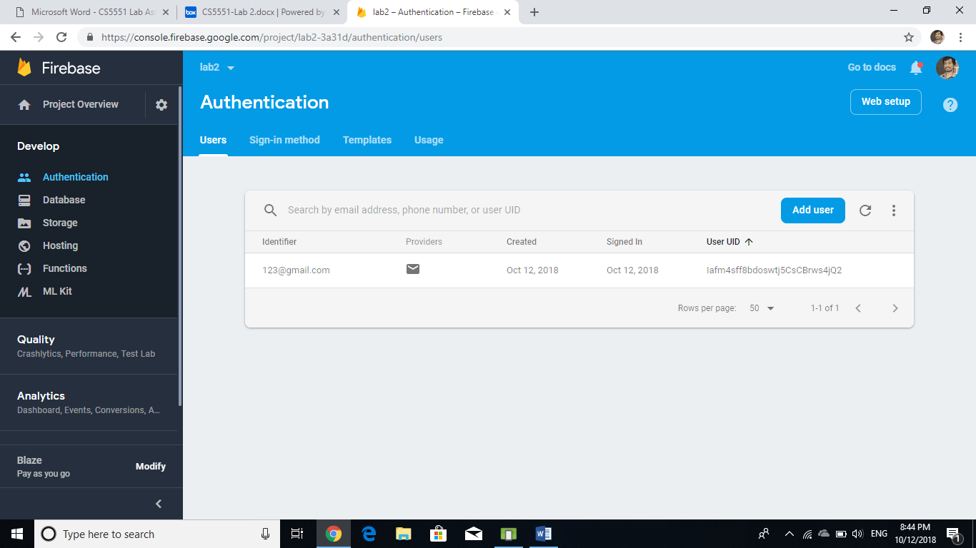

Design view of Login page

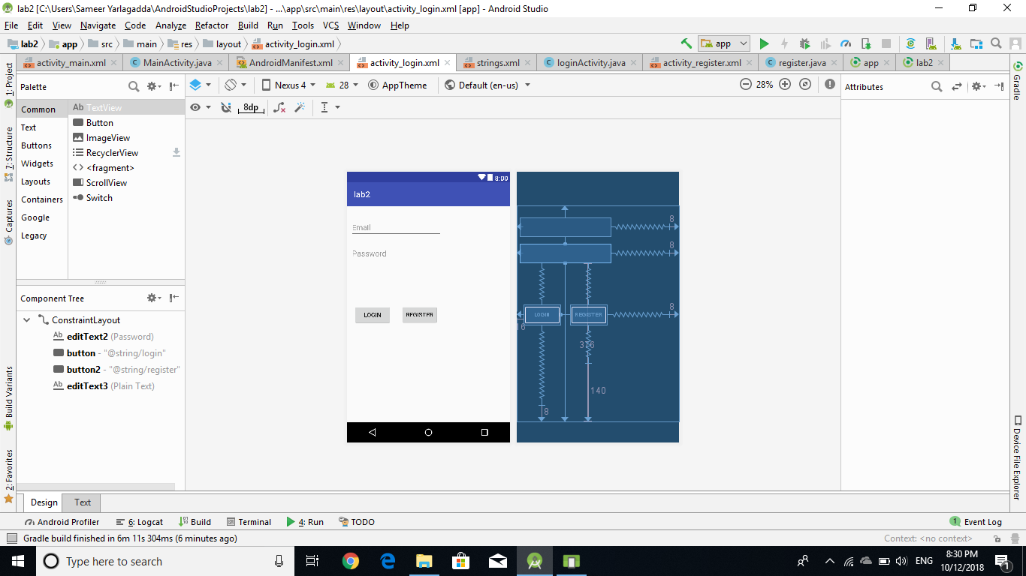

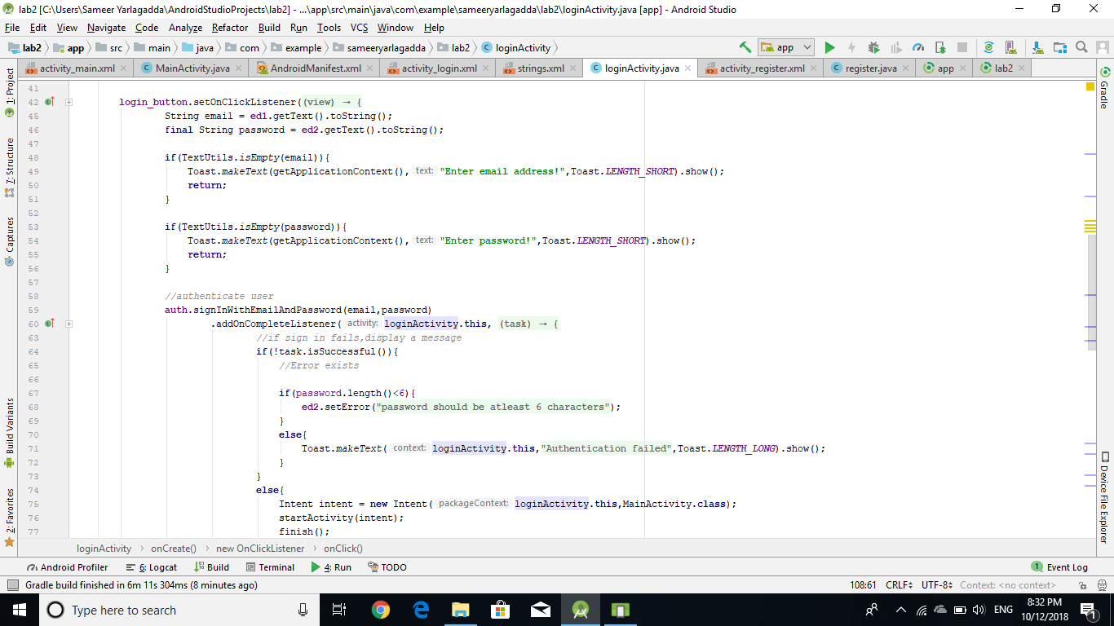

During Registration and login, Validation is performed.

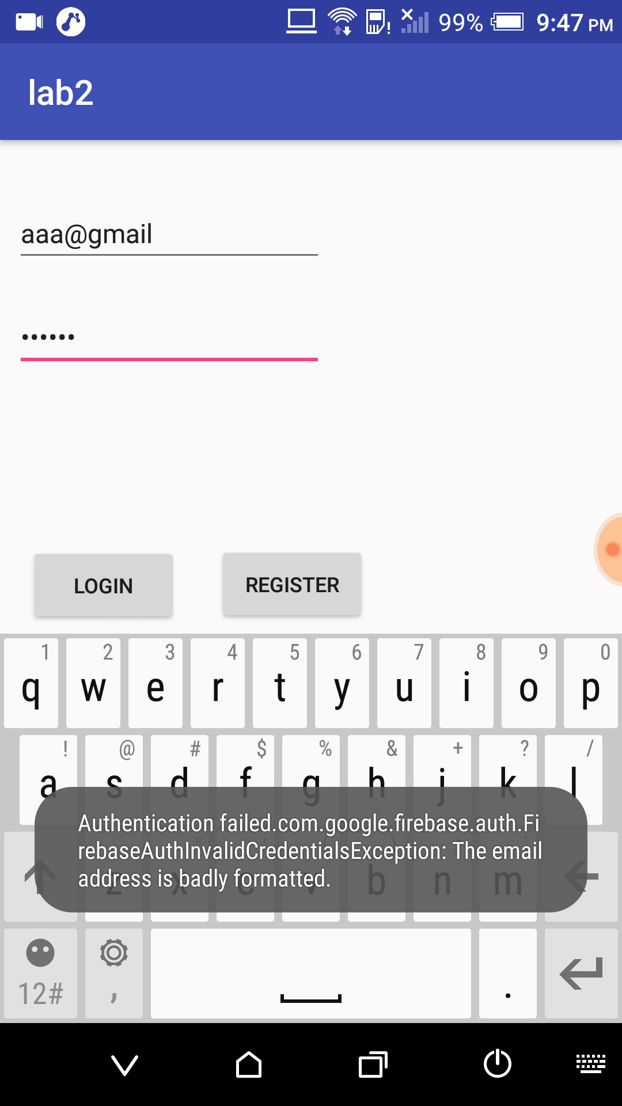

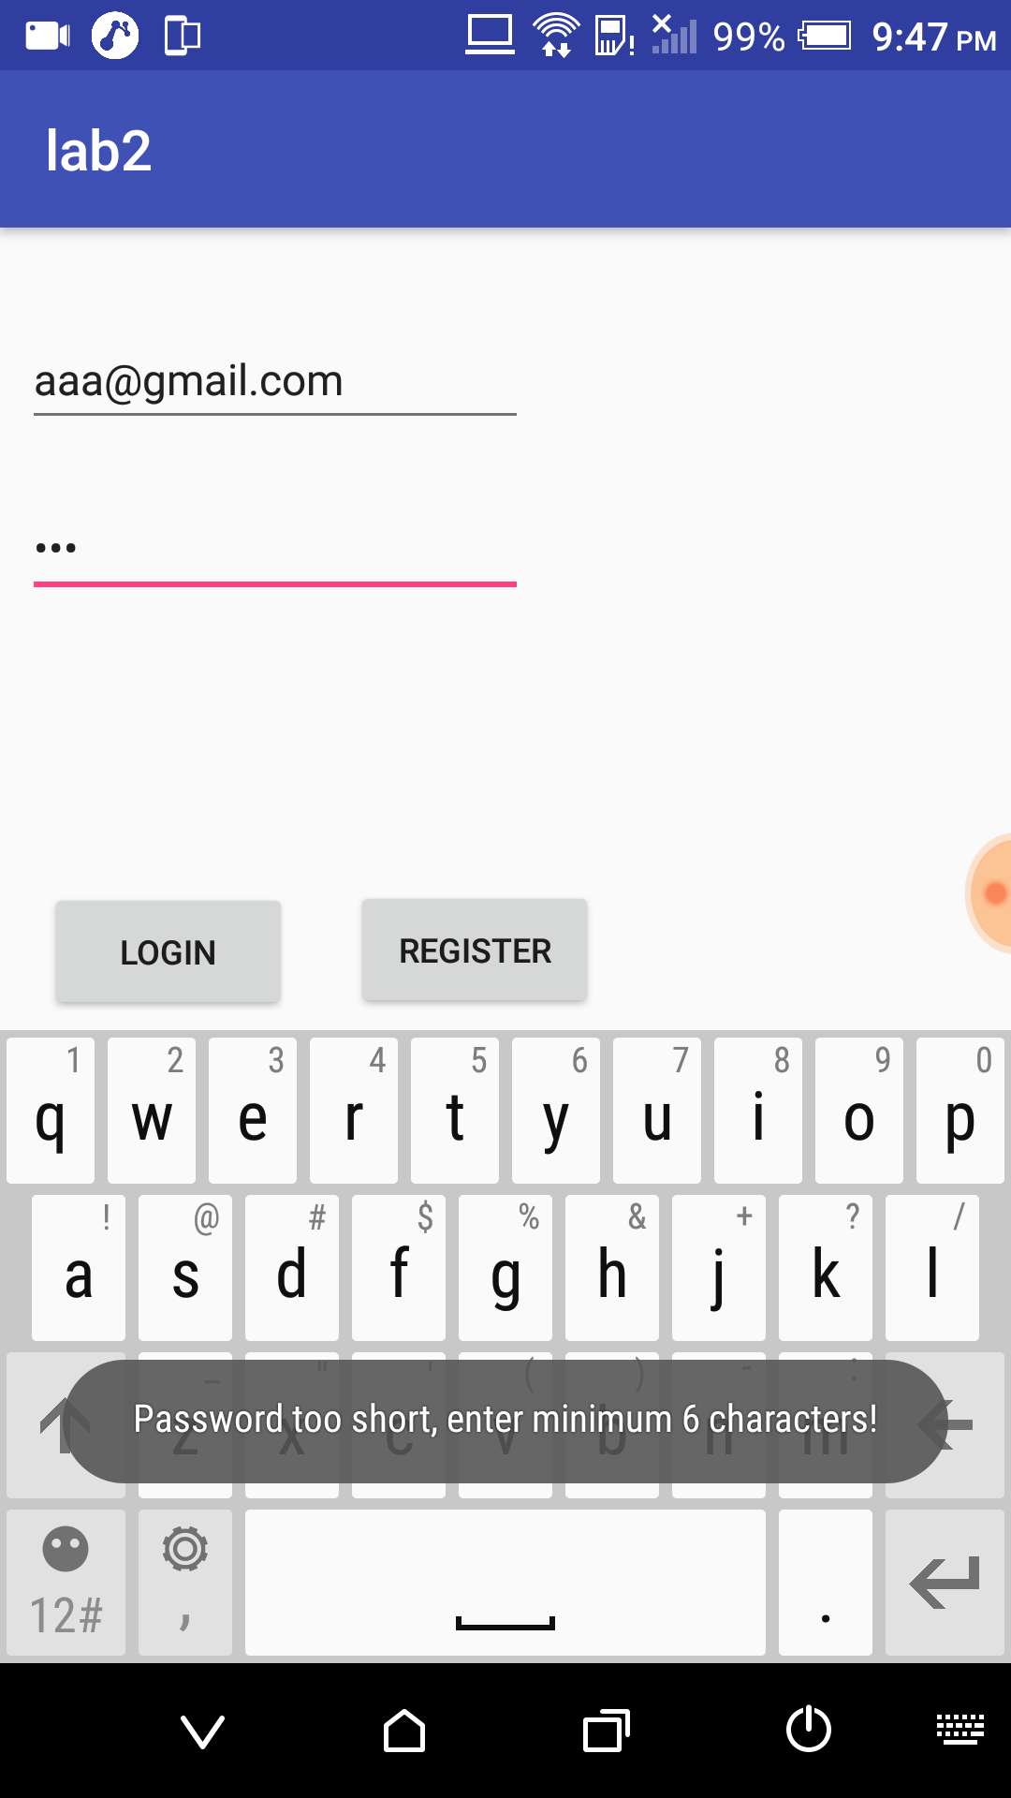

After successful registration and login app redirects the user to home page.

1. **Home page with Google Cloud Vision API:**

Here Google Cloud Vision API is used to extract the textual content from the image.

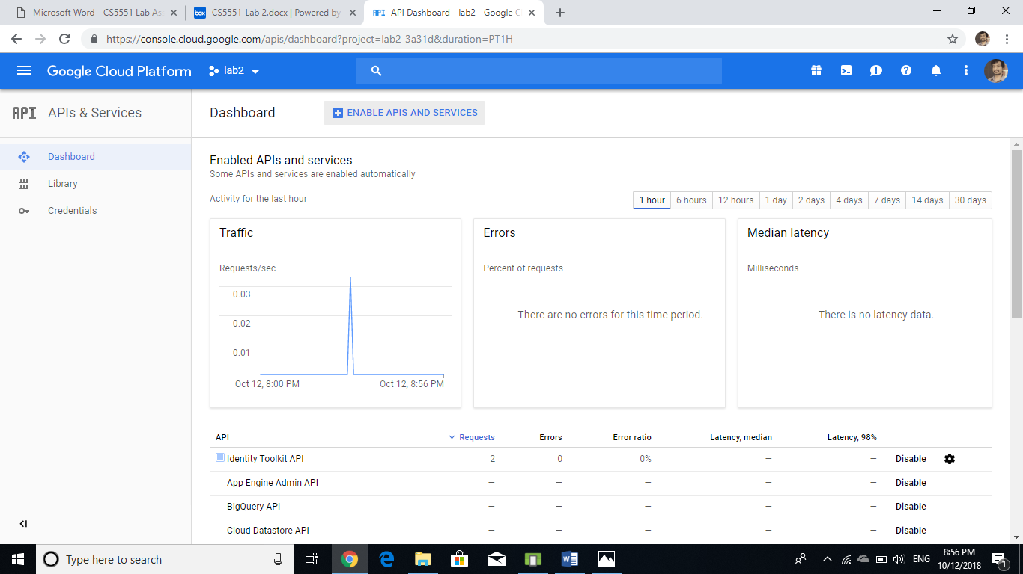

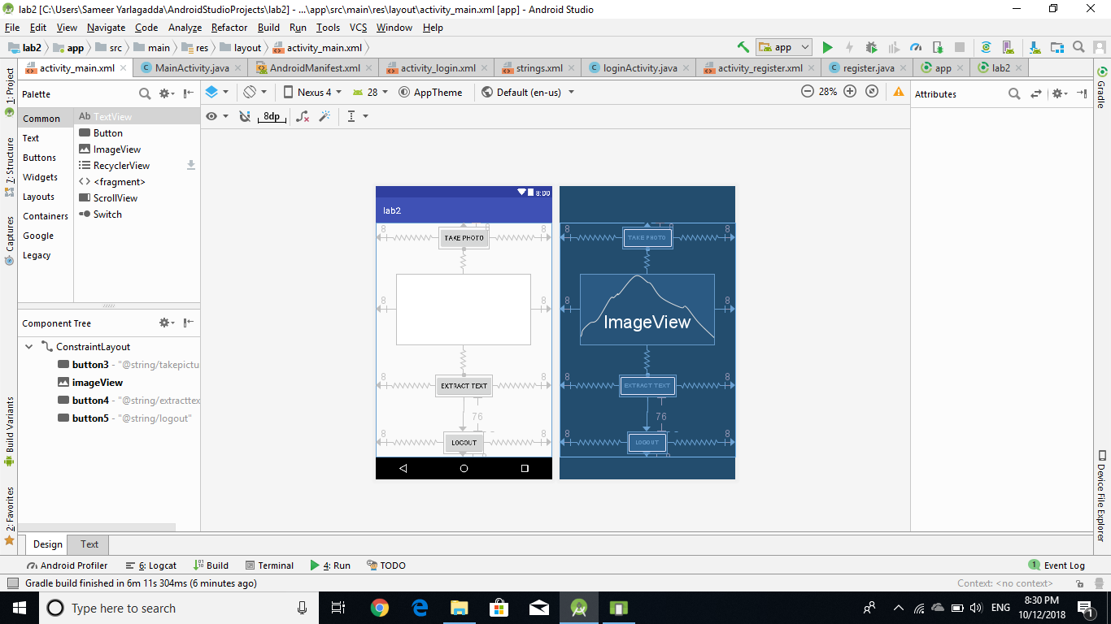

1. **Camera (hardware feature):**

When user clicks the button to “Take photo”, it initially requests the permission for camera to access the application.

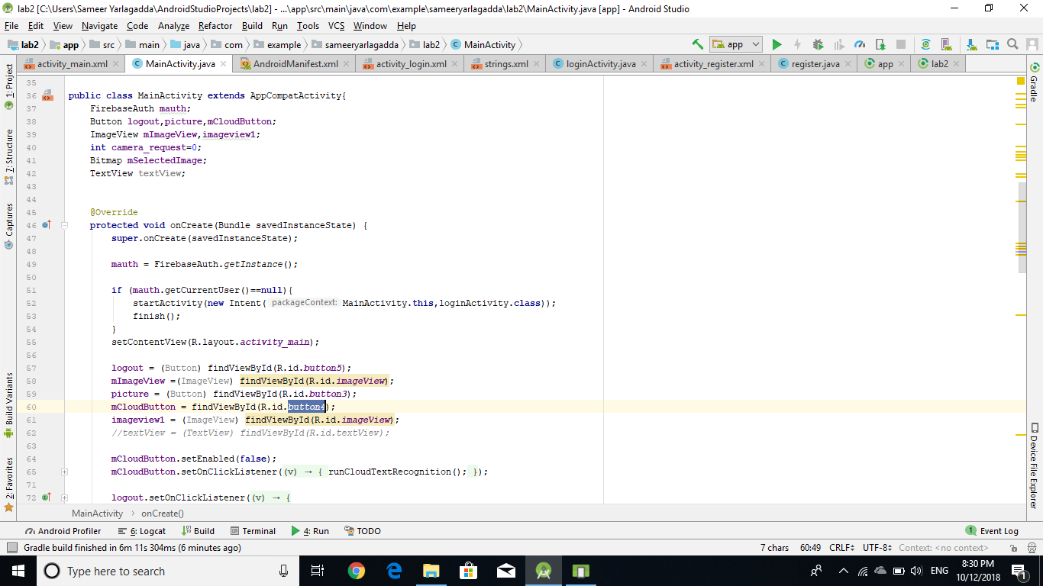

It then take a snap and after clicking the “Extract text” button, API extracts the text in the picture.

“runCloudTextRecognition()” is used for extraction of text from the image.

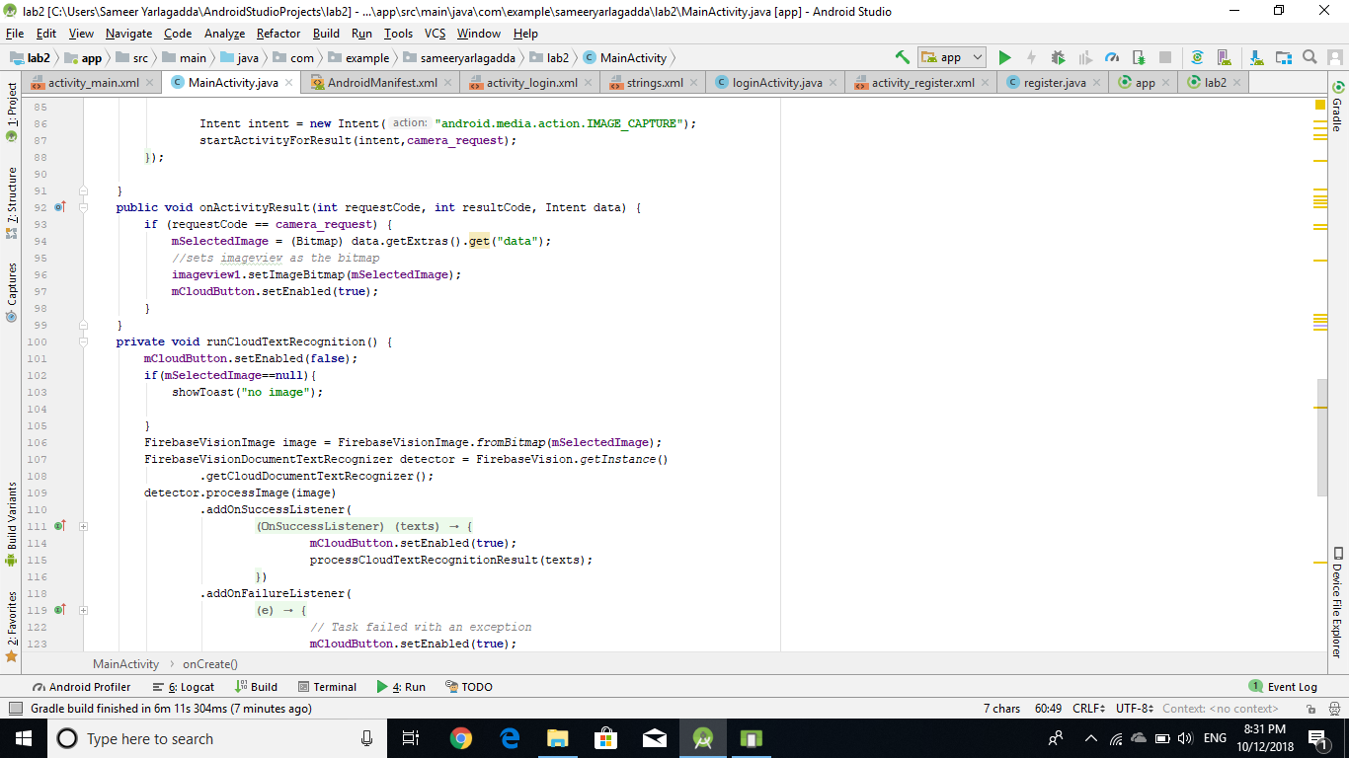

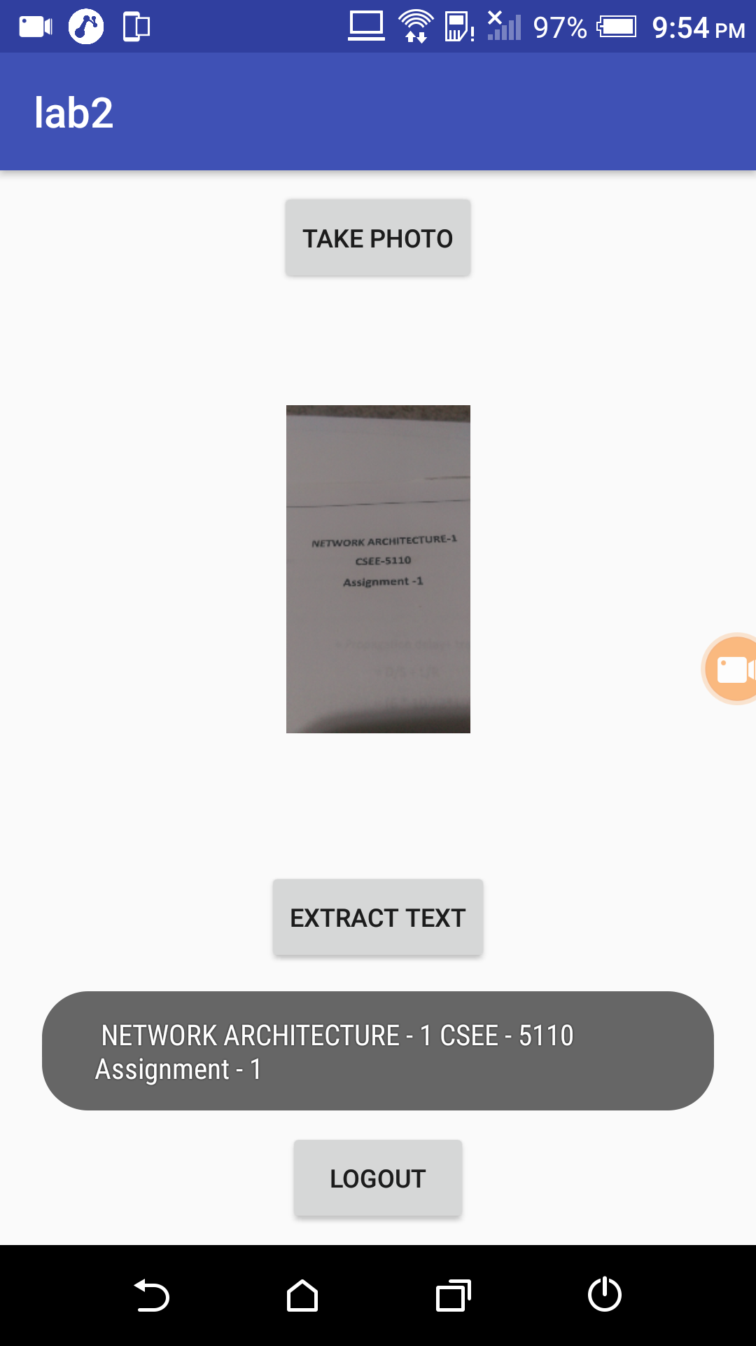

**Part-2**

**Objective:** To develop an Ionic Application with following features.

1. **Mashup application with different web services:**

After user logs in mashup page is loaded. Two API’s Clarifai and Kairos are used for Face and Visual detection in this application.

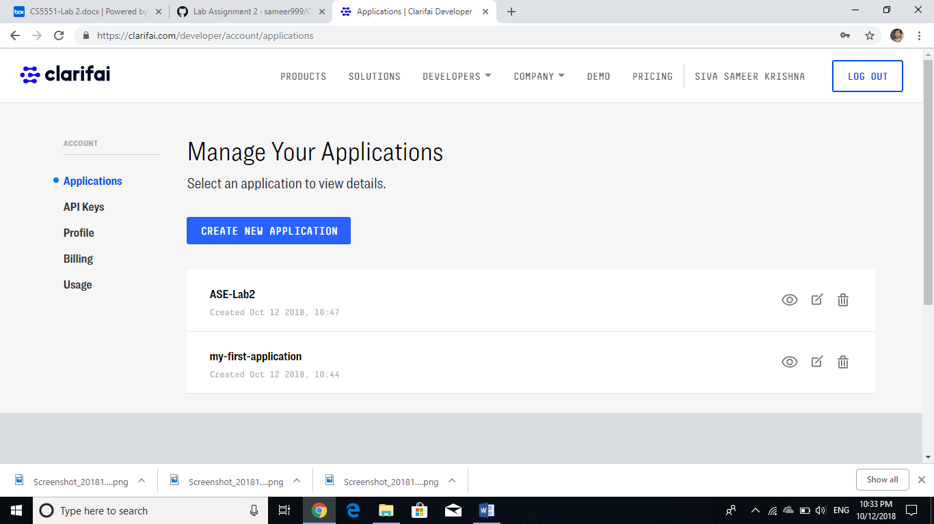

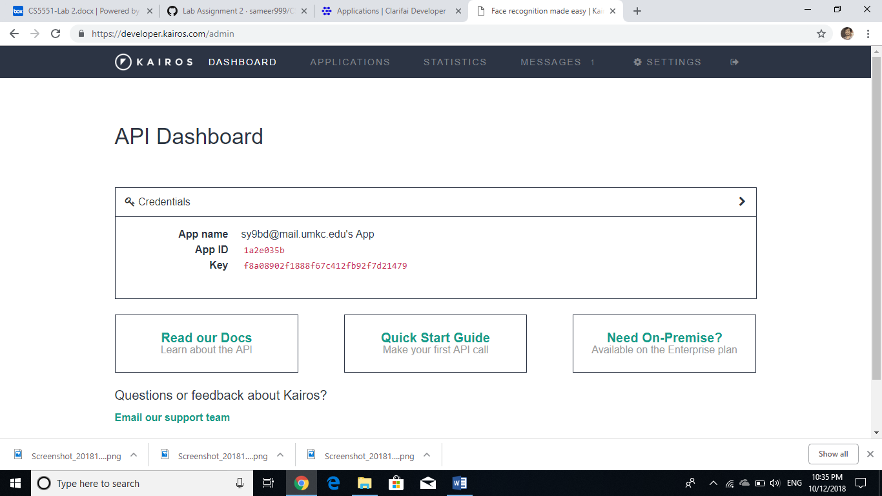

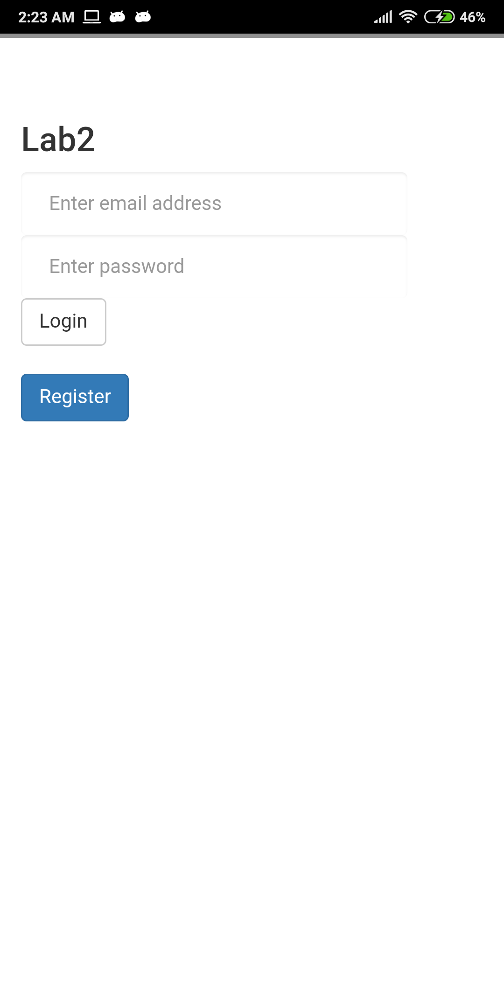

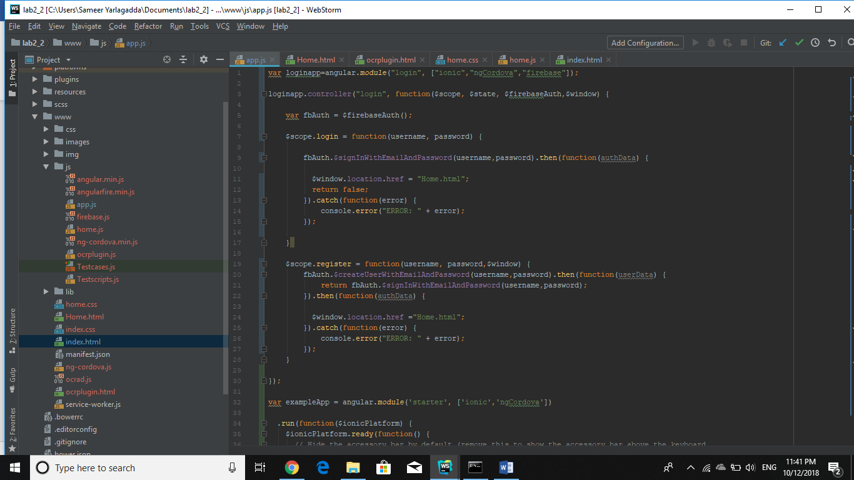

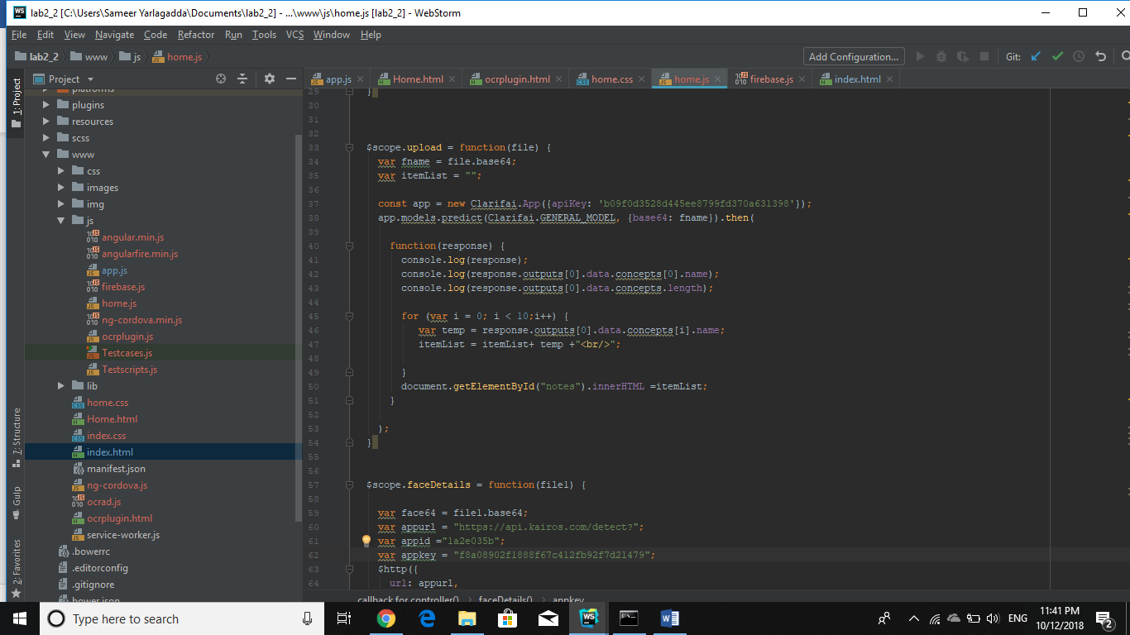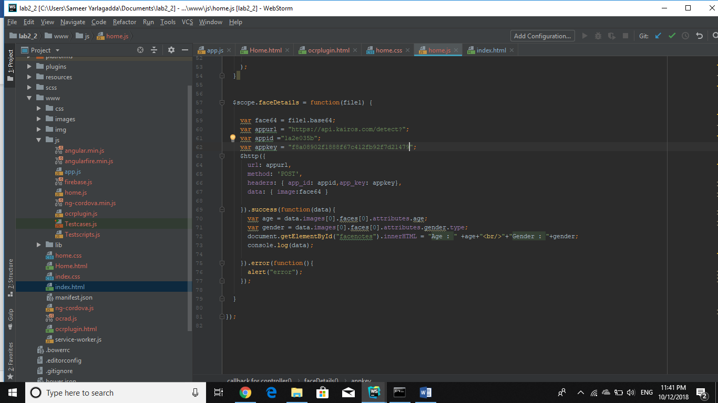

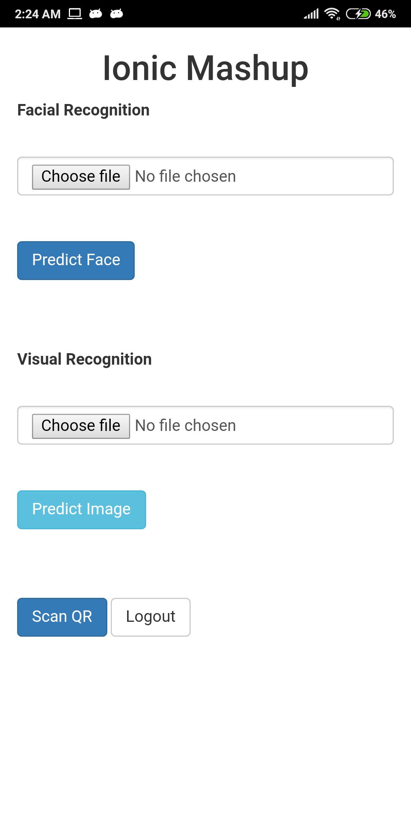

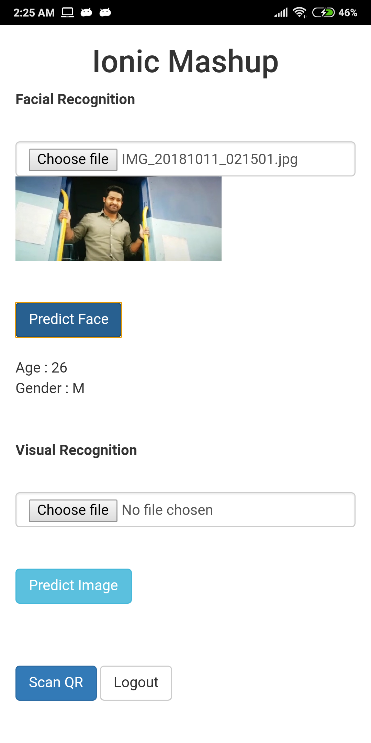

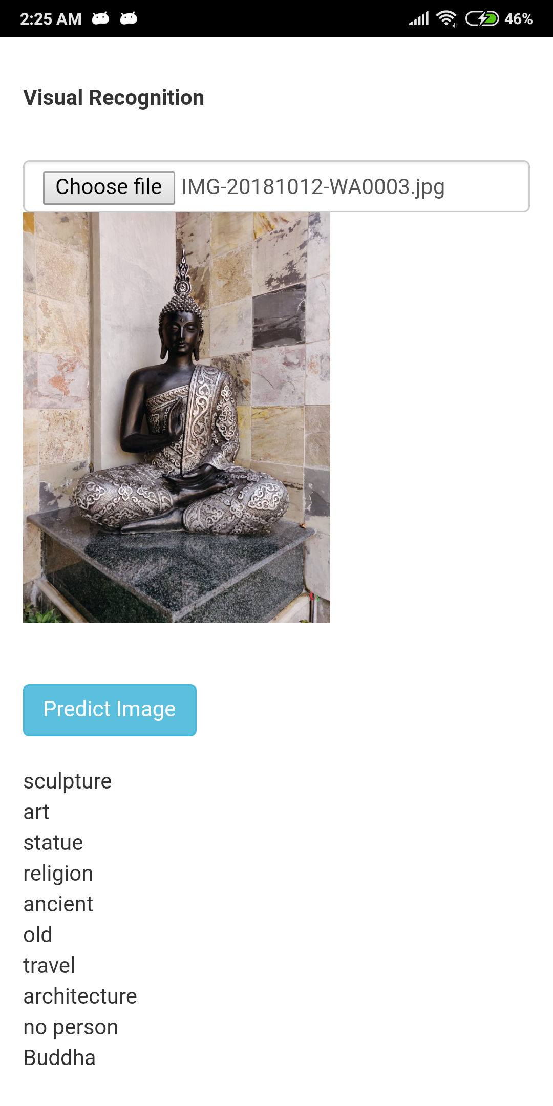

1. Cordova plugin: Bar code scanner is implemented.

It scans for different types of codes and returns the information present in it.

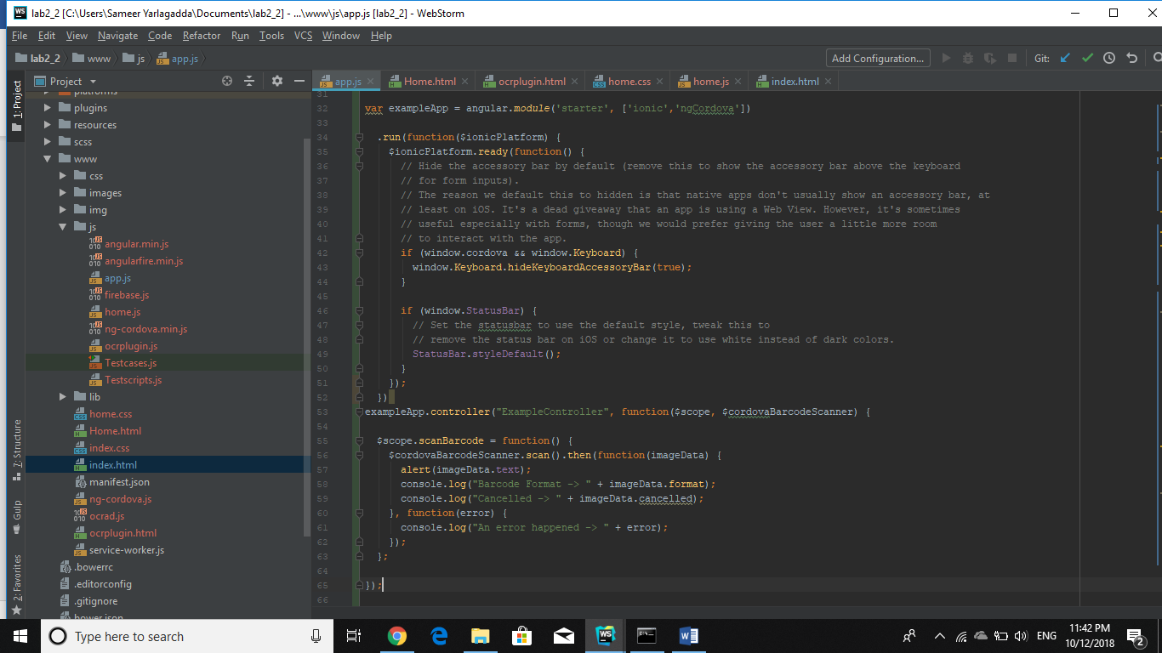

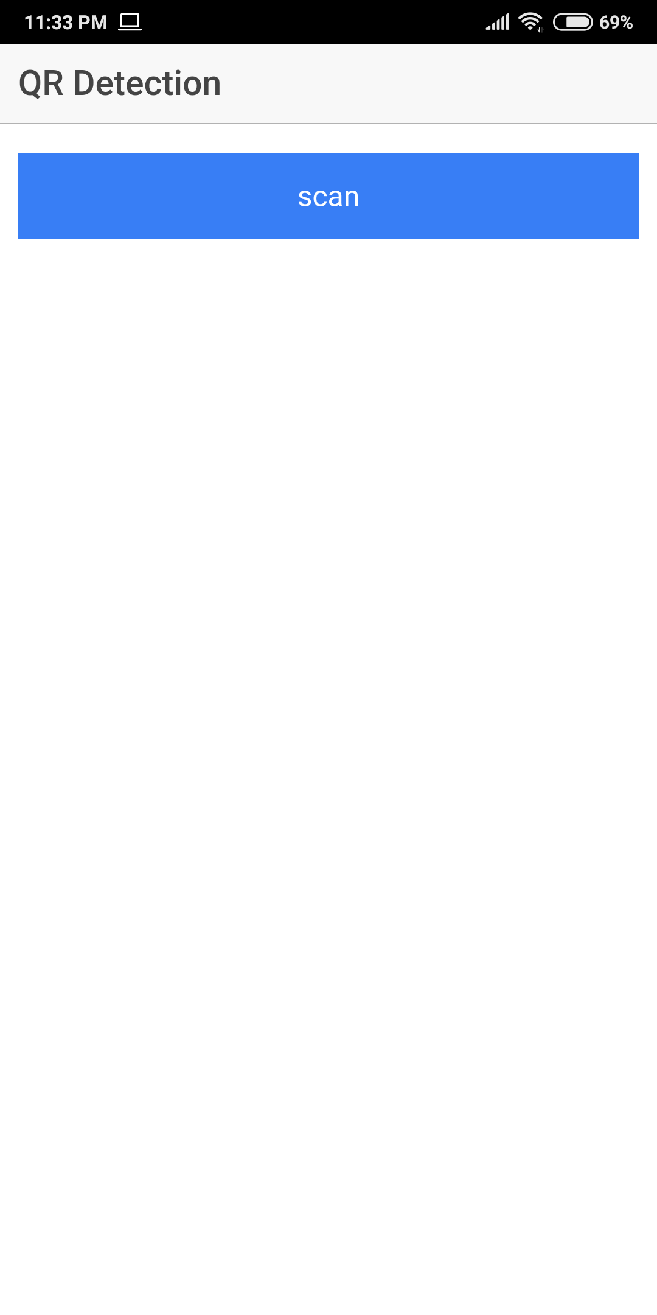

Bar code Scanner output:

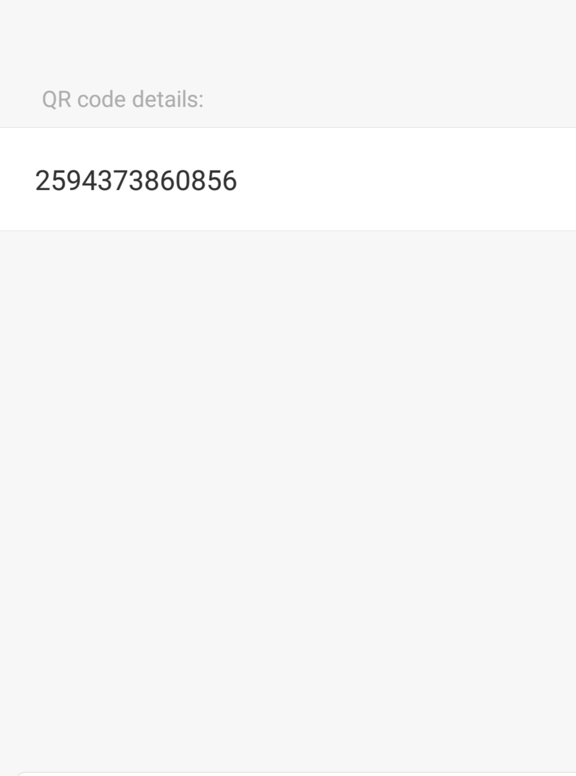

**References:**

1. <https://console.firebase.google.com>
2. <https://cloud.google.com/vision/>
3. <https://clarifai.com/developer/account/applications>
4. <https://www.kairos.com/docs/api/>
5. <https://developer.android.com/guide/>
6. <https://ionicframework.com/docs>
7. <https://www.thepolyglotdeveloper.com/2014/09/implement-barcode-scanner-using-ionic-framework/>